

**Western Australian Certificate of Education**

**ATAR course examination, 2020**

**Question/Answer Booklet**

12 PHYSICS

Name

**Test 2 – Gravitation & Equilibrium**

|  |  |  |  |  |  |  |  |  |  |  |
| --- | --- | --- | --- | --- | --- | --- | --- | --- | --- | --- |
| Student Number: In figures |  |  |  |  |  |  |  |  |  |  |

**Mark: $\frac{}{\text{4}\text{1}}$**  In words

#### Time allowed for this paper

Reading time before commencing work: five minutes

Working time for paper: fifty minutes

**Materials required/recommended for this paper**

To be provided by the supervisor

This Question/Answer Booklet

Formulae and Data Booklet

***To be provided by the candidate***

Standard items: pens, (blue/black preferred), pencils (including coloured), sharpener, correction fluid/tape, eraser, ruler, highlighters

Special items: non-programmable calculators satisfying the conditions set by the School Curriculum and Standards Authority for this course

**Important note to candidates**

No other items may be taken into the examination room. It is your responsibility to ensure that you do not have any unauthorised notes or other items of a non-personal nature in the examination room. If you have any unauthorised material with you, hand it to the supervisor before reading any further.

**Structure of this paper**

|  |  |  |  |  |  |
| --- | --- | --- | --- | --- | --- |
| Section | Number of questions available | Number of questions to be answered | Suggested working time  (minutes) | Marks available | Percentage of exam |
| Section One:  Short Answers | - | - | - | - | - |
| Section Two:  Problem-solving | 6 | 6 | 50 | 41 | 100 |
| Section Three:  Comprehension | - | - | - | - | - |
|  |  |  |  | **Total** | 100 |

**Instructions to candidates**

1. The rules for the conduct of examinations at Holy Cross College are detailed in the College Examination Policy*.* Sitting this examination implies that you agree to abide by these rules.

2. Write your answers in this Question/Answer Booklet.

3. Working or reasoning should be clearly shown when calculating or estimating answers.

4. You must be careful to confine your responses to the specific questions asked and to follow any instructions that are specific to a particular question.

5. Spare pages are included at the end of this booklet. They can be used for planning your

responses and/or as additional space if required to continue an answer.

• Planning: If you use the spare pages for planning, indicate this clearly at the top of the page.

• Continuing an answer: If you need to use the space to continue an answer, indicate in the original answer space where the answer is continued, i.e. give the page number. Fill in the number of the question(is) that you are continuing to answer at the top of the page.

6. Answers to questions involving calculations should be ***evaluated and given in decimal***

***form*.** It is suggested that you quote all answers to ***three significant figures***, with the

exception of questions for which estimates are required. Despite an incorrect final result, credit may be obtained for method and working, providing these are ***clearly and legibly set out***.

7. Questions containing the instruction "estimate" may give insufficient numerical data for their solution. Students should provide appropriate figures to enable an approximate solution to be obtained. Give final answers to a maximum of two significant figures and include appropriate units where applicable.

8. Note that when an answer is a vector quantity, it must be given with magnitude and direction.

9. In all calculations, units must be consistent throughout your working.

1. Drawn below is a vase used to hold flowers in the local church. The people supplying flowers have decided to place very long stemmed proteas into the vase for the Sunday service. Proteas have a very heavy head and a representation of one is drawn below.

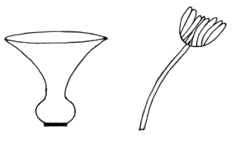

(a) Describe how 6 - 8 flowers should be arranged in order to make the combination stable. A simple drawing may be helpful. Assume no water is used in the vase.

(1 mark)



(b) Does the addition of water to the vase improve its stability? Explain your answer.

(2 marks)

(c) Explain why the vase is stable with or without water in it. (2 marks)

2. Calculate the force exerted by a biceps muscle when lifting a 3.00 kg mass. Assume the biceps muscle is attached 40.0 mm from the elbow joint and acts at right angles to the bone. The 0.400 m long lower arm has a mass of 1.70 kg and is considered uniform. (4 marks)

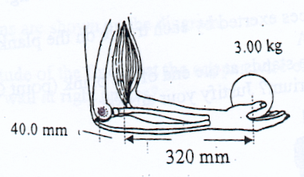

3. The moon Io is seen to revolve around Jupiter in a time of 18.6 hours at a radius of orbit measured to be 3.65 x 105 km. Io has a mass of 3.90 x 1022 kg.

(a) Use this information to calculate the mass of Jupiter. (3 marks)

(b) A probe sent to scan Io orbits at a height of 1.10 x 102 km above its surface in a pole- to-pole direction. The mass of the probe is 589 kg. Io has a mass of 3.90 x 1022 kg and a radius of 5.30 x 106 m.

(i) Determine the acceleration due to gravity acting on the probe. (3 marks)

(ii) Calculate the ***total energy*** of the probe as it orbits at this height above the moon.

(4 marks)

(c) Unfortunately, the probe encounters a severe micrometeor shower that knocks it into an elliptical orbit. Describe the changes in energy as the probe maintains this orbit. You may wish to label the diagram below. (2 marks)

4. A tightrope walker has recently been practising for a crossing of Niagara Falls by walking between two buildings in Toronto. The performer is 83.0 kg in mass and he carries a 7.50 m long pole that curves downwards to assist his balance. The walker is part of the way across the wire as shown below.

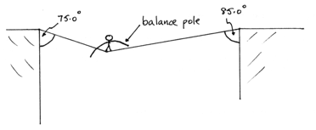

(a) Calculate the tension in each part of the wire. Ignore the mass of the wire and the pole. (4 marks)

(b) Give **one valid reason** why the performer uses such a long and curved pole for assisting balance. Explain your answer. (2 marks)

5. This question is about the gravitational field around an asteroid. The asteroid is spherical and of uniform density. The diagram below shows lines of equal gravitational field strength as dashed lines. There is a constant ratio in the value of the field strength between each line.

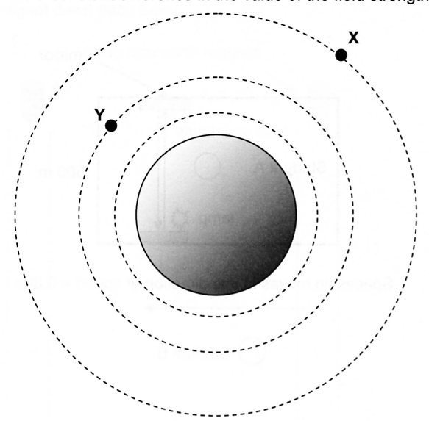

(a) Describe what the diagram shows about the gravitational field strength as the distance from the asteroid increases. (1 mark)

(b) Draw vectors to represent the gravitational field at points X and Y. (2 marks)

(c) The asteroid has a radius of 1.25 x 105 m. If the gravitational field strength on its surface is 0.194 Nkg-1, calculate the mass of the asteroid. (3 marks)

6. A support for a hanging pot plant consists of a 0.500 m long uniform rigid boom AD of mass

0.750 kg pivoted at the lower end and supported by a light rope to the wall as shown in the figure below.

The angles ABC and BAC are 45.0˚ and 60.0˚ respectively and the support cable BC is connected to the mid-point of AD at C. The mass of the pot plant and basket is 2.20 kg.

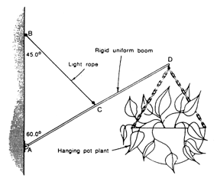

(a) On the diagram above, draw in all of the forces acting. (2 marks)

(b) Calculate the tension in the rope. (3 marks)

(b) Calculate the magnitude and direction of the force exerted by the wall on the boom at the point A. (3 marks)